**UPDuino Device Programming using the Adafruit FT232H Breakout Board**

Hardware Needed:

* Gnarly Grey UPDuino Board
  + <http://www.gnarlygrey.com/development-platform.html#upduino>
* Adafruit FT232H Breakout Board
  + <https://learn.adafruit.com/adafruit-ft232h-breakout/overview>

Software Needed:

* Lattice Diamond Programmer Standalone (v3.9 x64 used for programming instructions)
  + <http://www.latticesemi.com/en/Products/DesignSoftwareAndIP/ProgrammingAndConfigurationSw/Programmer.aspx#_20C94305815A4B3AAAFEA8B83943B751>
* Lattice iCECube2 Software (
  + <http://www.latticesemi.com/Products/DesignSoftwareAndIP/FPGAandLDS/iCEcube2.aspx#_4351BE10BA504435B5226390CF5D7D4C>

FPGA Projects Needed:

* UPDuino Blinky LED Design
  + <http://www.gnarlygrey.com/downloads/RGB_LED_BLINK_20170606.tar>

FT232 to Lattice iCE FPGA Pinout:

* FT232 Pins
  + D0 - ICE_SCK
  + D1 - FLASH_MOSI/ICE_MISO
  + D2 - FLASH_MISO/ICE_MOSI
  + D4 - ICE_SS
  + D7 – CRESET
  + GND – GND
  + 5V – 5V
* UPDuino Pins
  + Note – If you want to program SRAM directly you need to treat FLASH_MISO as MOSI and FLASH_MOSI and MISO so that you program the FPGA directly in slave mode. Basically, just swap the MISO and MOSI pins around.
  + J1 jumper must be shorted for SPI flash operation
  + JP1 jumper needs to be connected to CRESET (pin closest to FPGA is CRESET, pin furthest away is GND)

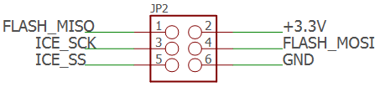

Programming (SPI Flash):

1. Open Lattice Diamond Programmer
2. Click ‘Detect Cable’ then ‘OK’
3. After scanning select ‘Generic JTAG Device’ and ‘Select iCE40 UltraPlus’
4. Under ‘Device’ click iCE40UP3K and change it to iCE40UP5K
5. Under ‘Operation’ double click ‘Fast Program’ and change ‘Access Mode:’ to ‘SPI Flash Programming’
6. Select your *.hex programming file under ‘Programming file’.
7. Configure the following ‘SPI Flash Options’
   1. Numonyx
   2. SPI-N25Q032
   3. 8-pin VDFPN8
8. Click ‘Load from File’ under ‘SPI Programming’ to get load size
9. Click ‘Design’🡪’Program’

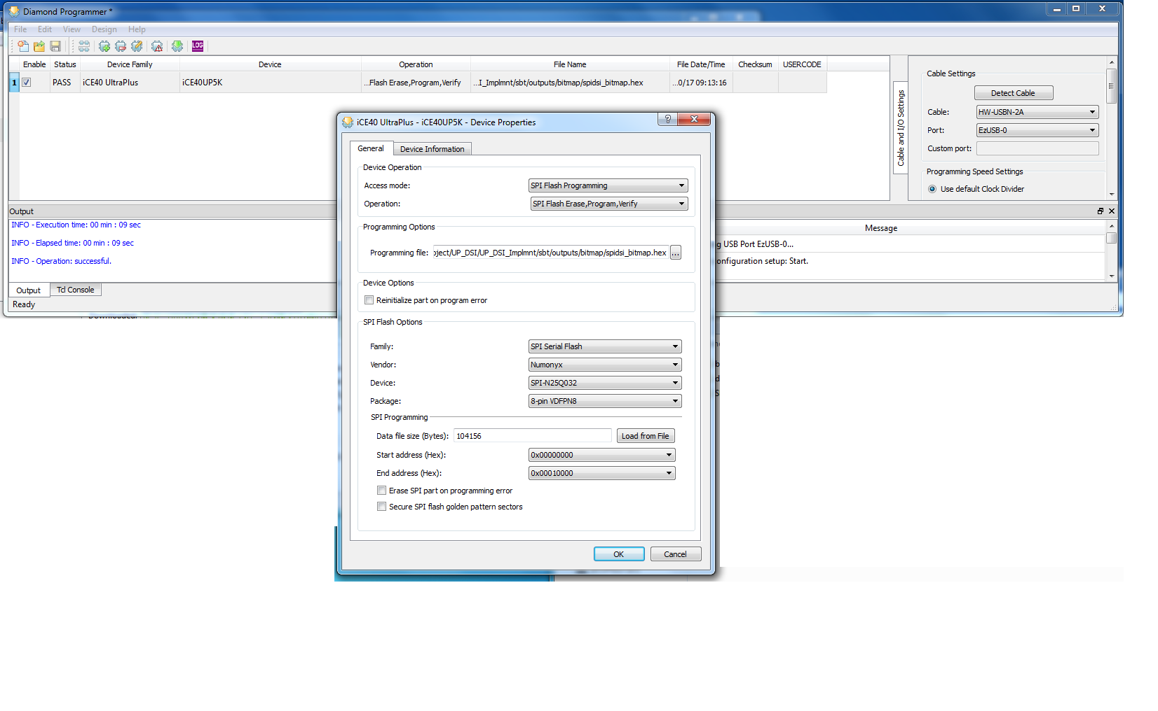

Programming (Internal SRAM):

1. Open Lattice Diamond Programmer
2. Click ‘Detect Cable’ then ‘OK’
3. After scanning select ‘Generic JTAG Device’ and ‘Select iCE40 UltraPlus’
4. Under ‘Device’ click iCE40UP3K and change it to iCE40UP5K
5. Click ‘Design’🡪’Program’

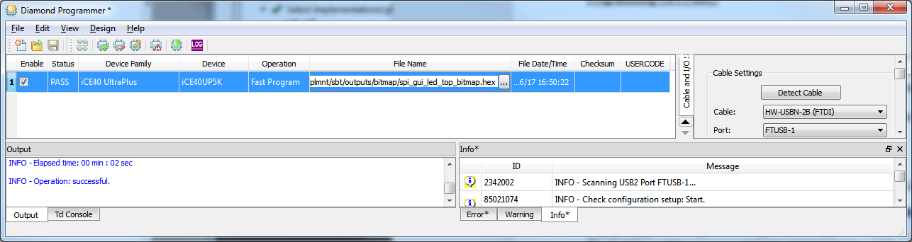

Project Synthesis (Compiling) and bitstream (Firmware) generation:

1. Unzip RGB_LED_BLINK_20170606.zip
2. Open Lattice iCECube2 Software
3. Double click ‘Open Project’
4. Navigate to *\RGB_LED_BLINK_20170606\rgb\rgb_sbt.project and ‘Open’
5. Double click ‘Run Synplify Pro Synthesis’
6. Right click on ‘Run P&R’ and left click ‘Run Bitmap’
   1. Note – this will run all remaining synthesis steps including place, route and bitmap generation.
   2. Generated bitstream will be loaded in the *\rgb\rgb_Implmnt\sbt\outputs\bitmap folder